Making a Green Wood Cloche

Tools:
- Bypass pruners
- Wire cutters
- Pliers
- Needle nose pliers or needle nose vice grips
- Safety glasses
- Gloves
- 3 ceramic or clay garden pots with holes in bottom, 5” to 6” in height

Materials:

- Spool of wire – 20 to 22 gauge
- Lengths of 20 to 22 gauge wire cut to the following lengths – (8-10) 18”, (8) 12” and (8-10) 6 “ (Approximate number of pieces required)
- 3 - 12” to 18” pieces of 18 gauge wire to serve as anchor points
- Green wood (cut within 2 to 3 days)
  - 5 lengths of about 5 feet (these can be shorter if you want a smaller or shorter cloche)
  - 8 lengths of about 3 feet
Note: (If you don’t have long enough pieces of green wood, you can make longer pieces out of shorter ones. Place two pieces of green wood on a worksurface. With thick portions at opposite ends and laid side-by-side, pull ends away from each other until you have the required length. Attach with wire in middle and at the ends of the shorter pieces)

Extras for Embellishment:
- Raffia
- Natural twine
- Nylon cord
- Long lengths of holly
- Vines like wisteria, ivy (not poison)

Make a Ring
Gently persuade one of the long green wood pieces into a circle with an overlap of 3 to 6” to get the diameter you wish. Bind with wire in center of overlap and at both ends. You can also twist the pieces together before binding

Trim overlapped end to follow curve of ring.

Starting at the thickest part of the overlapped ring, securely wrap wire and pull it directly across the ring. Adjust tension to make ring more circular then securely attach the wire to the end. 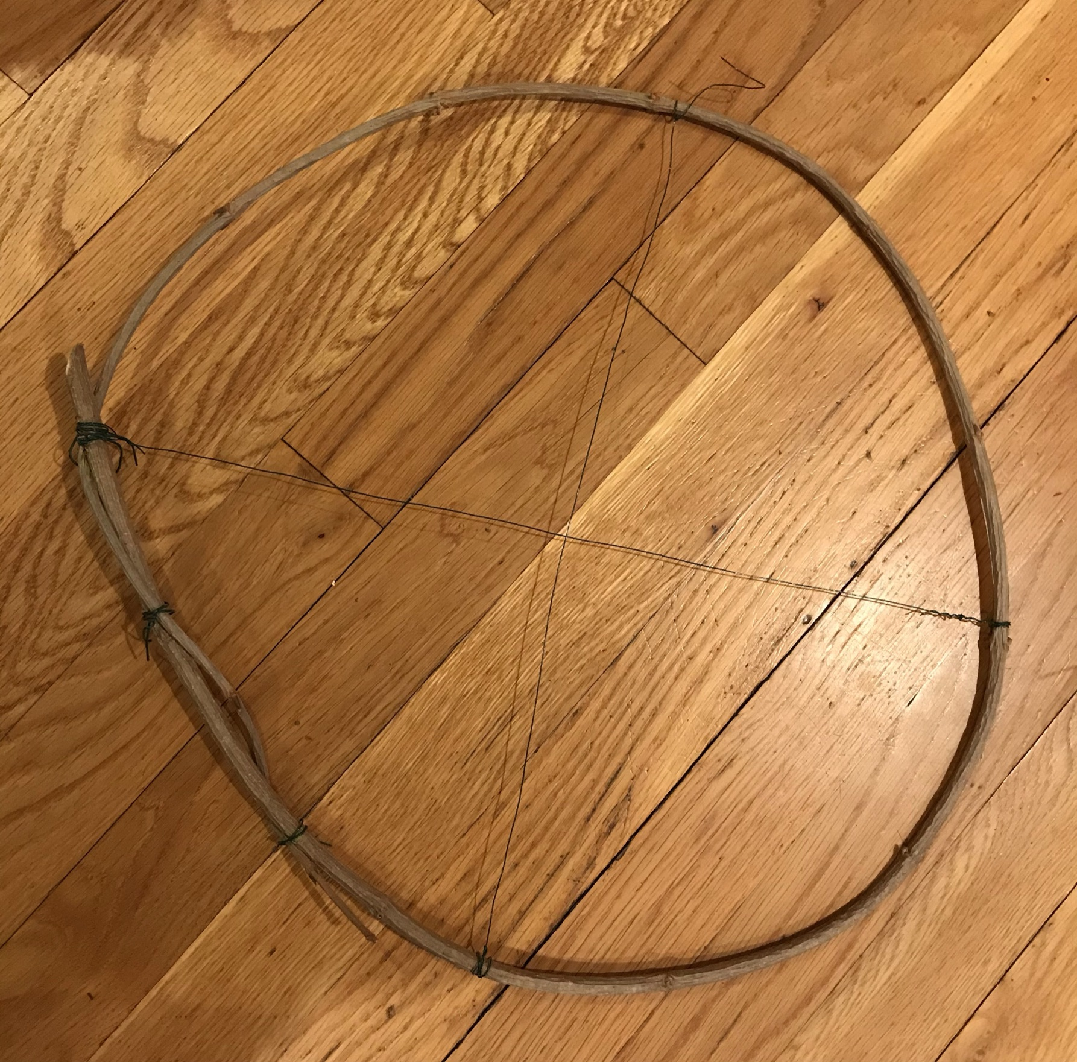

Continue running wires across the diameter of the circular frame three more times. Adjust tension each time to make ring rounder. Bind the intersection of the 4 wires together with a short piece of wire. (If you have had to apply more tension to one section than the others and the placement of the wires are not equal around the ring, bind the intersection with the most wires.)
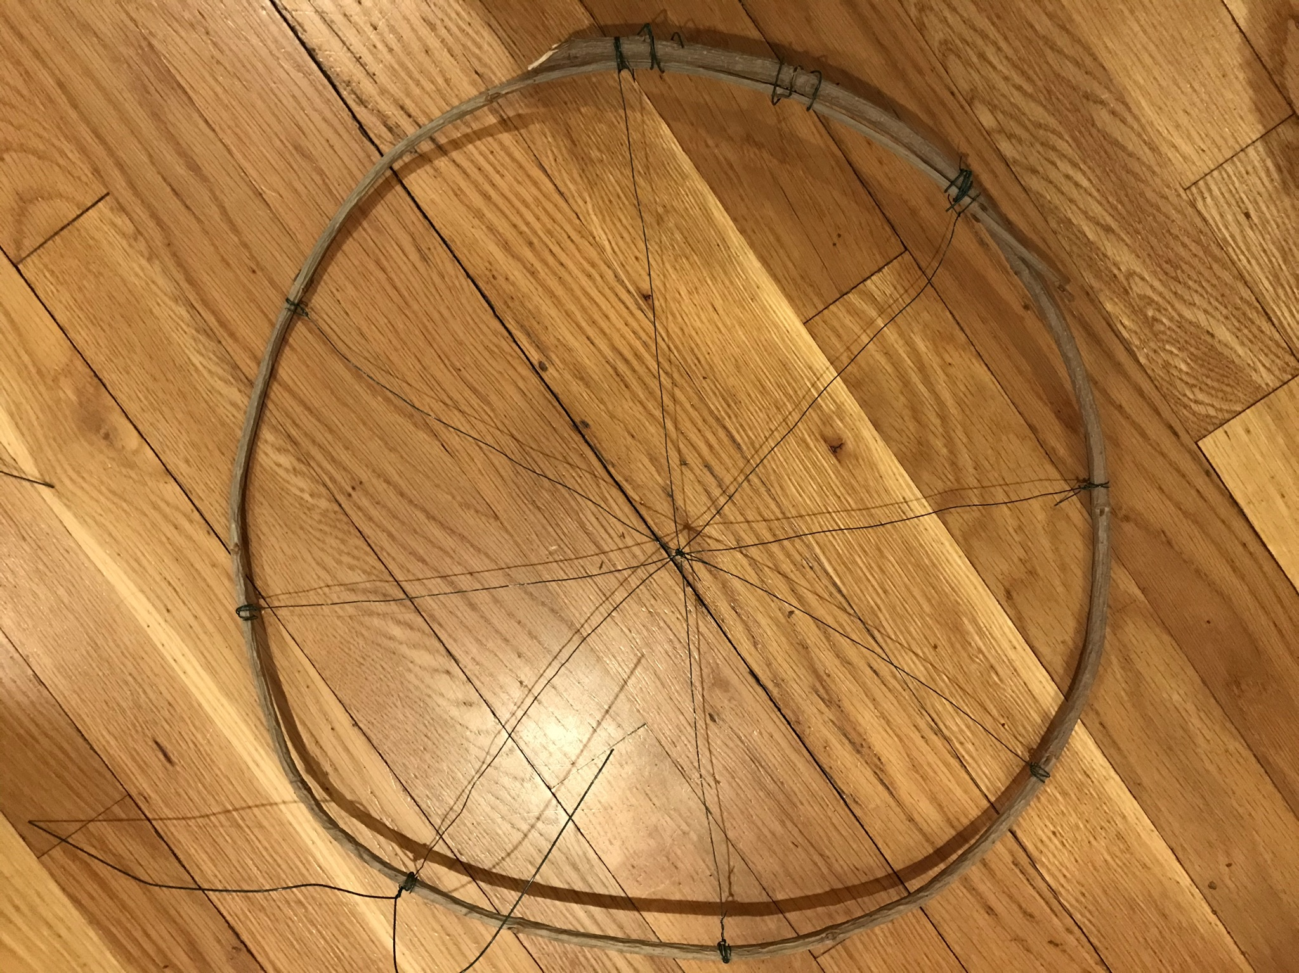

Bend 8 -18” wires in half, then twist them around the ring at each of the 8 places where the wires you used to make your ring more circular are wrapped around the ring.
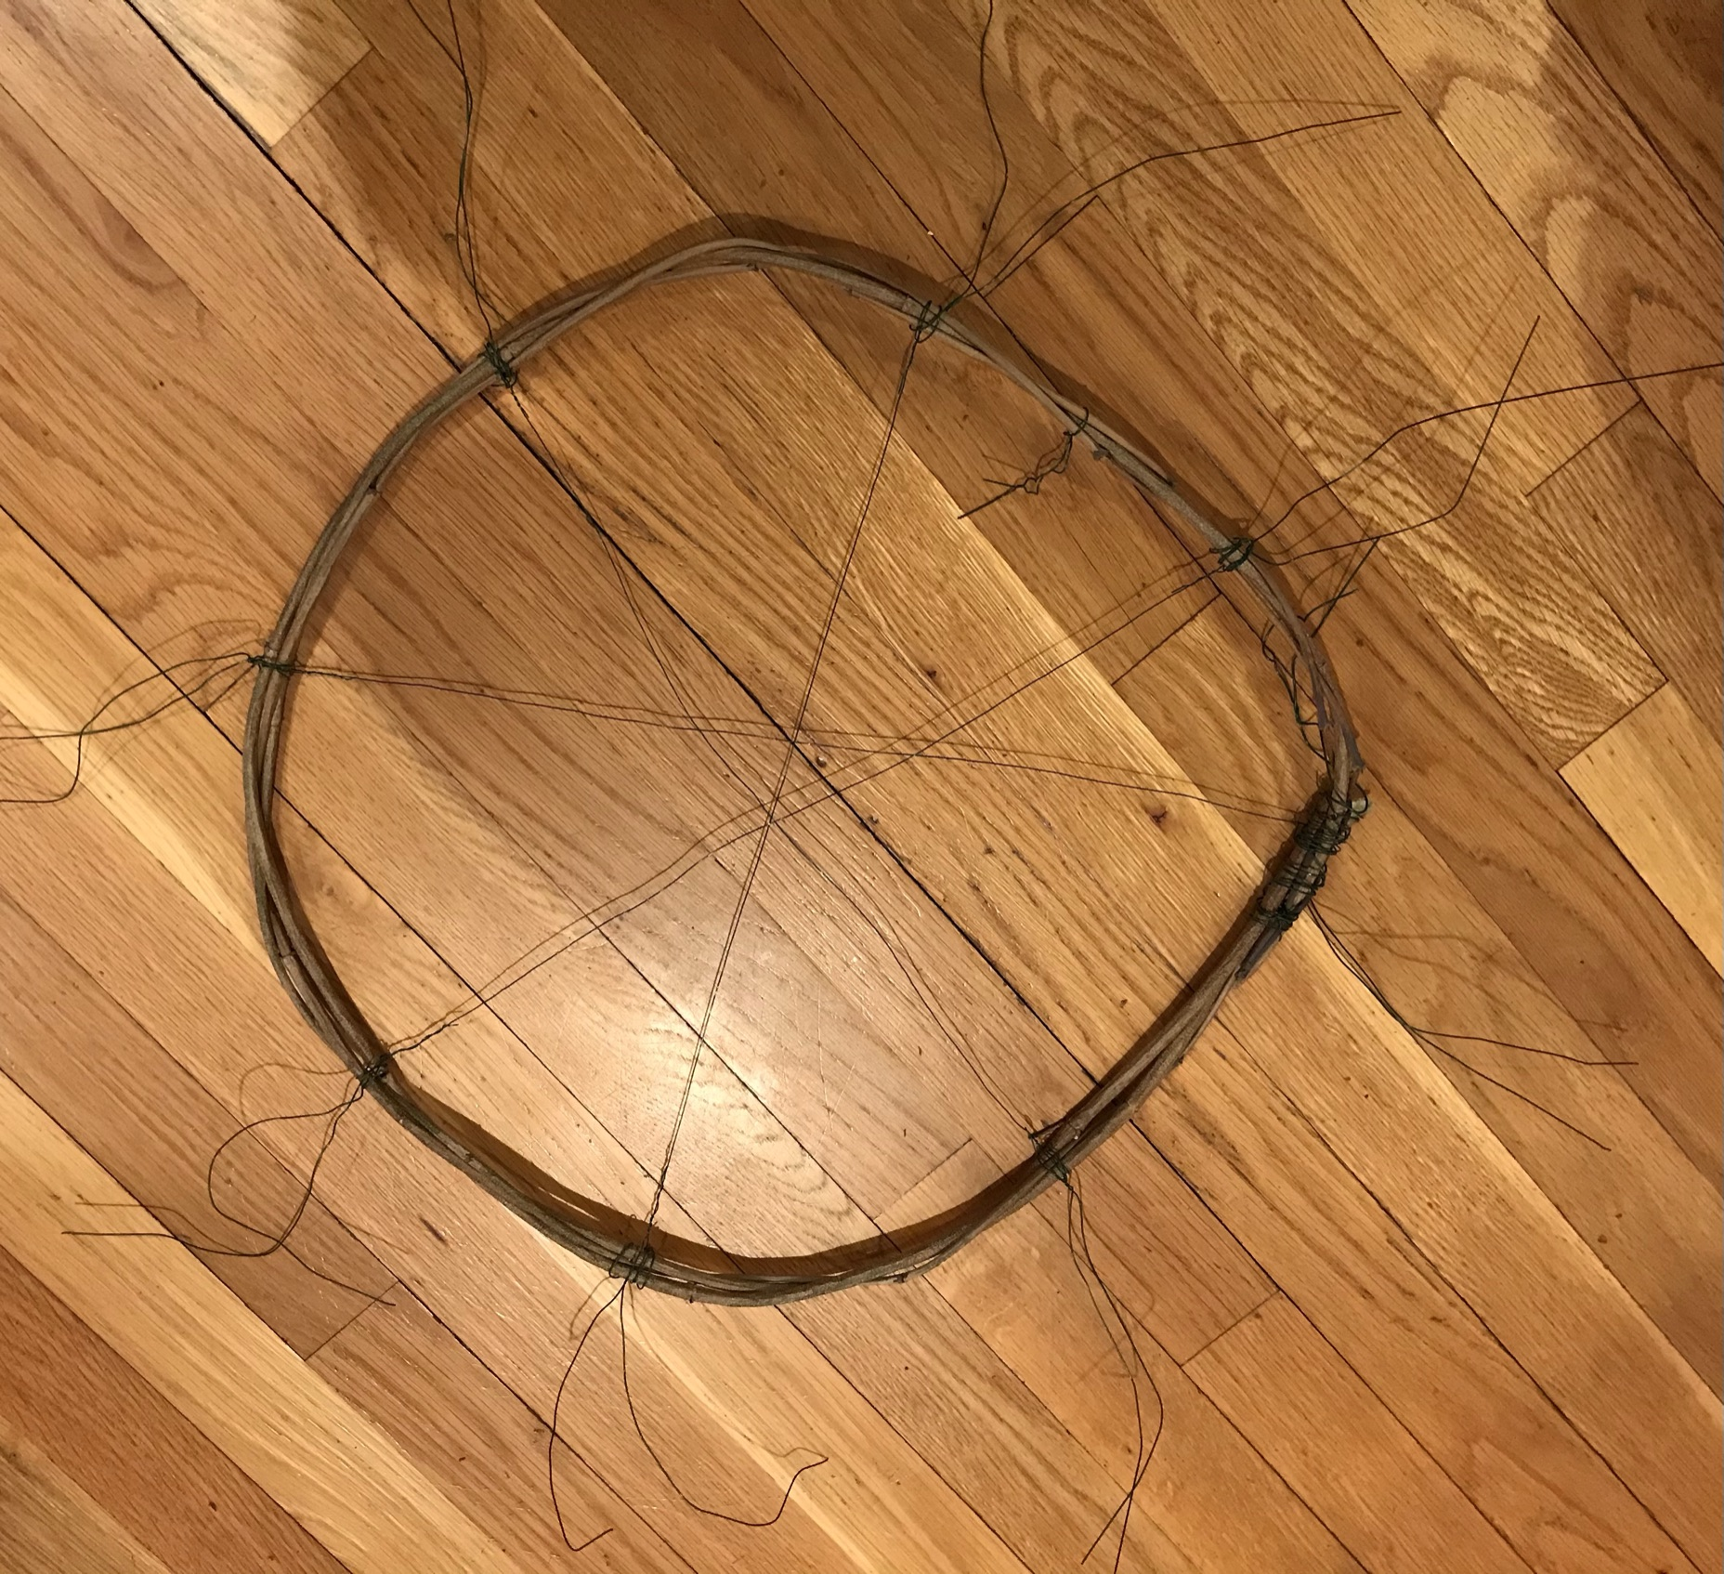

Attach Three Pots to Ring
Tightly twist an 18” wire (center of wire on ring) around the ring at each of the eight points of attachment on the ring.

Lay ring on table and with a 6” piece of wire centered on the ring (centered between two of the eight attachment points), place the wire around the ring and through the hole at the bottom of the pot. Take a piece of discarded green wood, which fits tightly across the bottom of the pot, wrap wire around the bit of wood in the pot and twist to secure it. This should not be an incredibly tight connection as you may need to slide the pot when you are attaching supports. You can also tape the wood and wire in the inside of the pot if it should come loose. Place another two pots and attach equidistant around the ring.

Flip all pots over and your ring should be elevated to the height of the pots.

Bend Wood to Form Structural Arches

You need four long pieces of green wood for the arches. Lay them side by side and cut them so that they are of four lengths, with the shortest as #1 and the longest as #4. There should be an inch progression for each one from shortest to longest.

Take the shortest of the long pieces of green wood and persuade it gently to bend enough to fit within the ring. Using the wire you previously attached to the ring, bind the wood to the ring with each end of the green wood legs on the worksurface and across the diameter of the ring.

Continue with your next shortest piece (should be about ½” to and 1” longer than the first) and bend to fit in the position perpendicular to the first support.

Center the two supports in relation to the structure and each other. Use an 18” wire to attach these two supports at the top, perpendicular to each other. You will use this same wire to attach the next two supports.

Continue with the next shortest piece of green wood, matching larger ends with the smaller ones around the base. Center arch over other supports and bind with the wire. Finish with the final longest piece of green wood. You may have to add another piece of wire to bind all four supports securely together.

Attach Eight Short Arches
Attach a 12” piece of wire to each support leg, an inch up from the work surface.
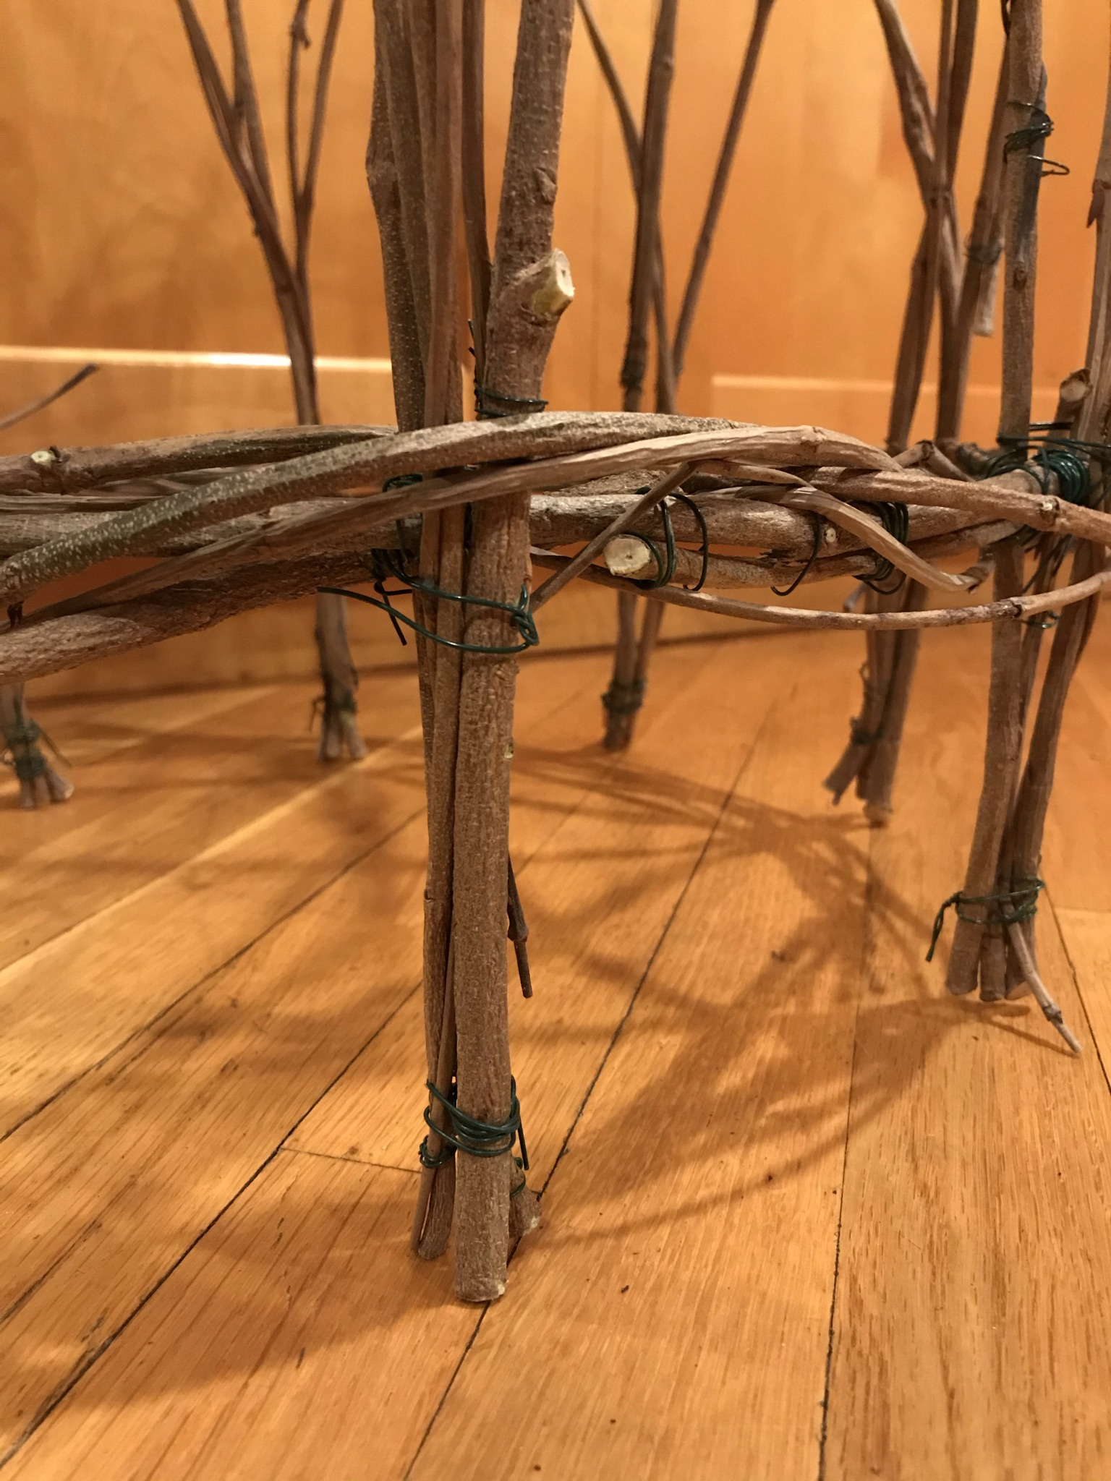

With one of the 36” pieces of green wood, place the thick end of the wood next to one of the thin support ends. Attach with the wires on the supports and ring. Secure tightly, but leave enough wire to include one other piece of wood.

Attach the next short piece of greenwood to the support leg which is crossed by the first arch. Bend it to the 1st leg past the 1st arch. You will now have your next arch crossing the first arch. Continue in this fashion until you have three pieces of greenwood for each leg support and all 8 shorter pieces are incorporated into the structure.

Tighten all ends of the wires.

That’s it. You have made a green wood cloche. You can cover the wire with vines, raffia, holly, twine or just leave them as you like. You can also add another ring to the top and change up the pattern. Just make sure there are enough structural attachments to make the cloche strong.

Placing Your Cloche in Your Garden or Pot
When you place your cloche in the garden, it will tip or fall over unless you bury the legs in the soil or anchor it with garden staples. If you bury the legs, your cloche will decay more rapidly. So we recommend using garden staples to anchor it to the ground.

How Attach a Garden Staple to Your Cloche
Using needle-nose pliers or needle-nose vice grips, hold the end of a piece of 18 gauge wire and turn it to make a small ring. Turn it again to have a second ring directly over the first. Bend the wire so that it is perpendicular to the ring. Wrap tightly up one of the support legs, keeping the ring parallel to the worksurface. Make two more of these and attach to two other support legs spaced as close to equidistant as you can.

Anchor in your garden with the garden staples.

